Found pass for level 0-1
Level 0: Logged into the Bandit server using SSH and explored the home directory. Used the ls and cat commands to read the readme file and obtain the password for the next level.
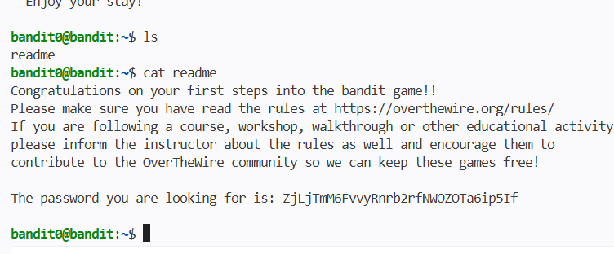

Found pass for 1-2
Level 1: Learned how to access a file named -, which is treated specially by Linux commands. Used cat ./- to read the file and retrieve the password for the next level.

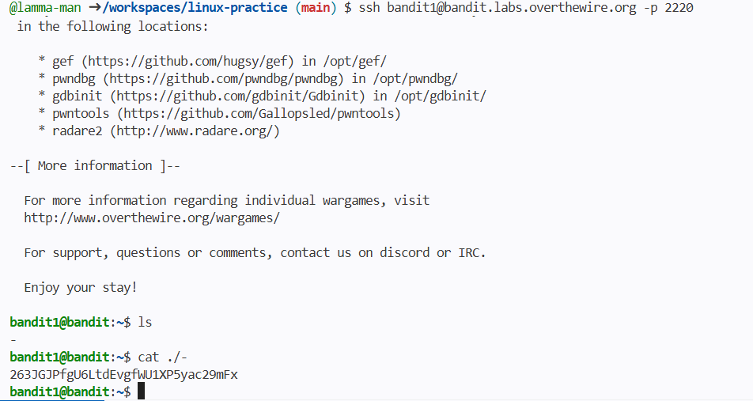
Found pass for lev 2-3
Level 2: Learned how to work with filenames that contain spaces. Used quotes or escaped spaces with the cat command to read the file and obtain the password for the next level.

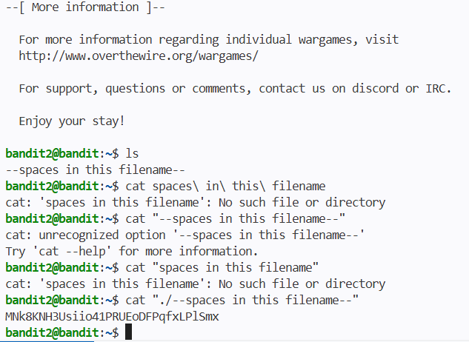
Found pass for 3-4 level
Level 3: Navigated into the inhere directory and discovered a hidden file using the ls -a command. Read the hidden file with cat to retrieve the password for the next level.
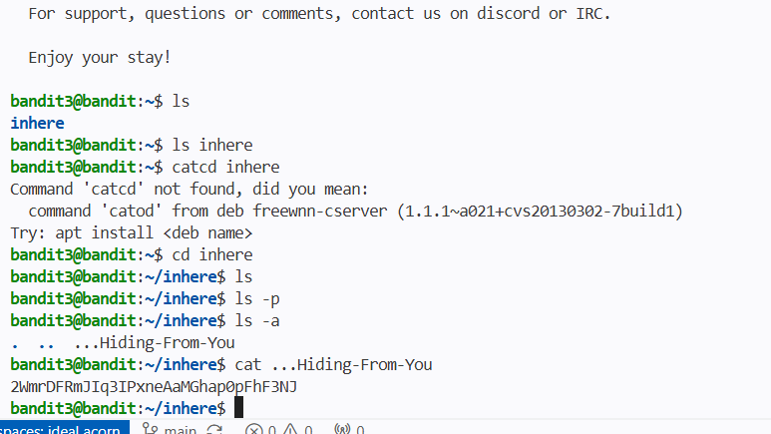
Found pass for lev 4-5
Learned how to identify a human-readable file among many files using file
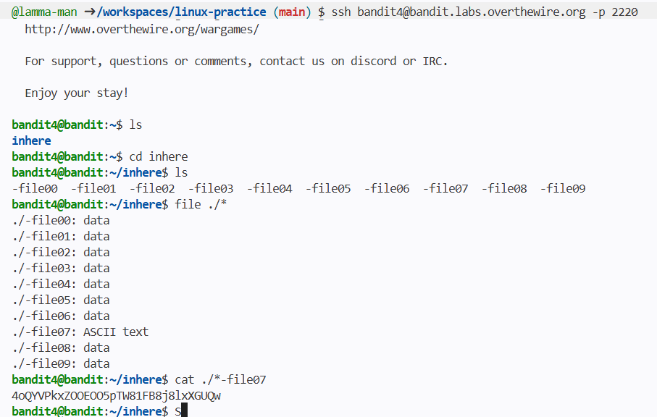

Found pass for level 5-6
Learned how to search for a file using find with conditions like size and permissions
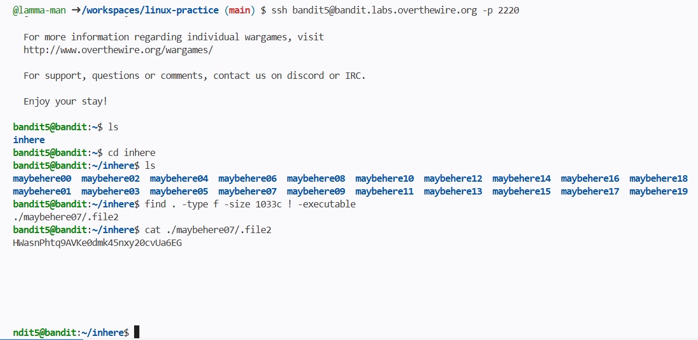

Fouind password for level 6-7
Learned how to find a file anywhere on the system by searching with its owner, group, and size
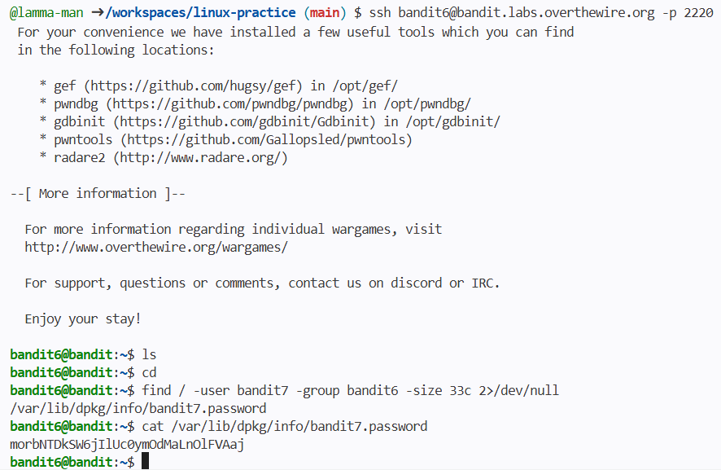
found pass for 7-8th lev
Learned how to search for a specific word inside a file using grep
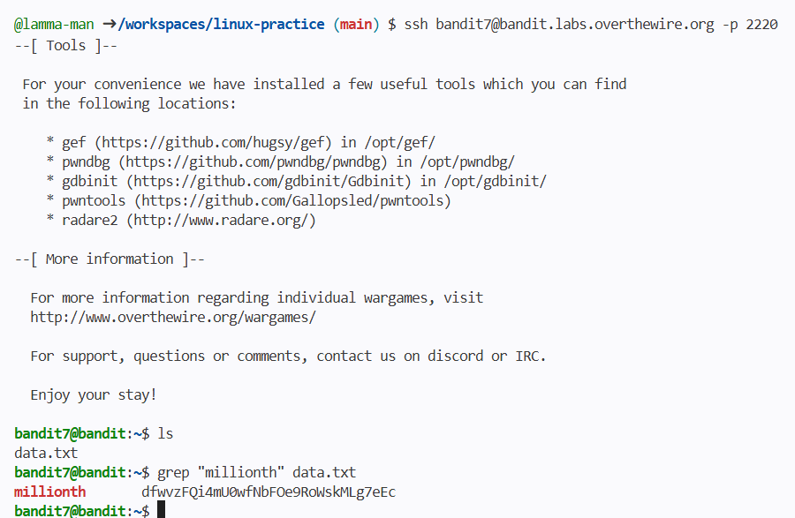

Found pass for level 8- 9
Learned how to remove duplicate lines and find the unique one using sort and uniq
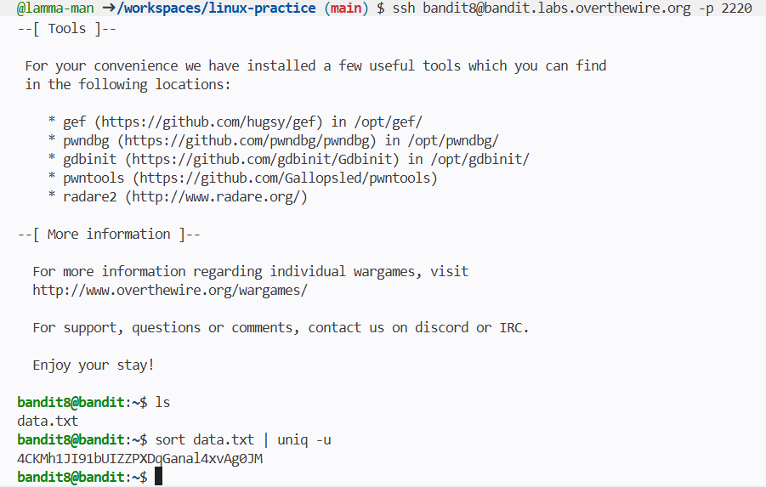
Found password for 9-10th
Learned how to find readable text hidden inside a binary file using strings
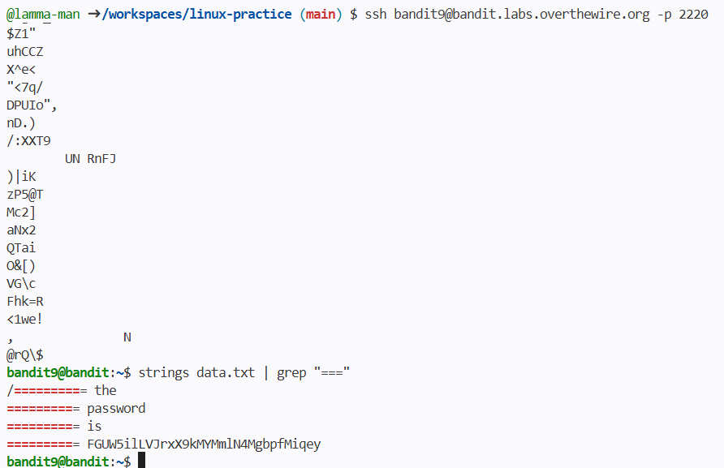

Found password for 10-11tth
Learned how to decode Base64 text using base64 -d
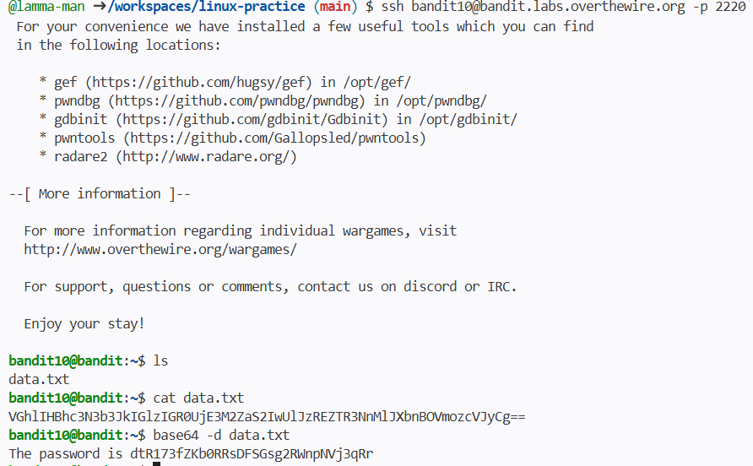
found password for 11-12th
Learned how to rotate letters (ROT13) using tr to decode a message.
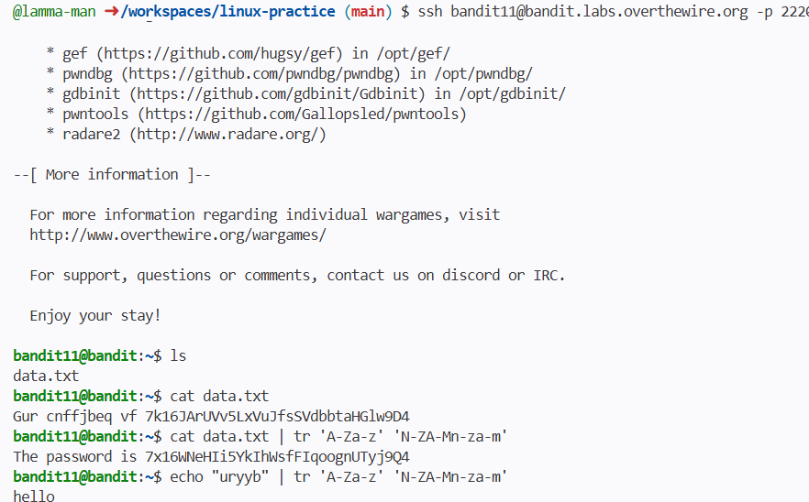

Found password for 12-13
Learned how to repeatedly decompress files (gzip, bzip2, tar, etc.) until reaching the final text file.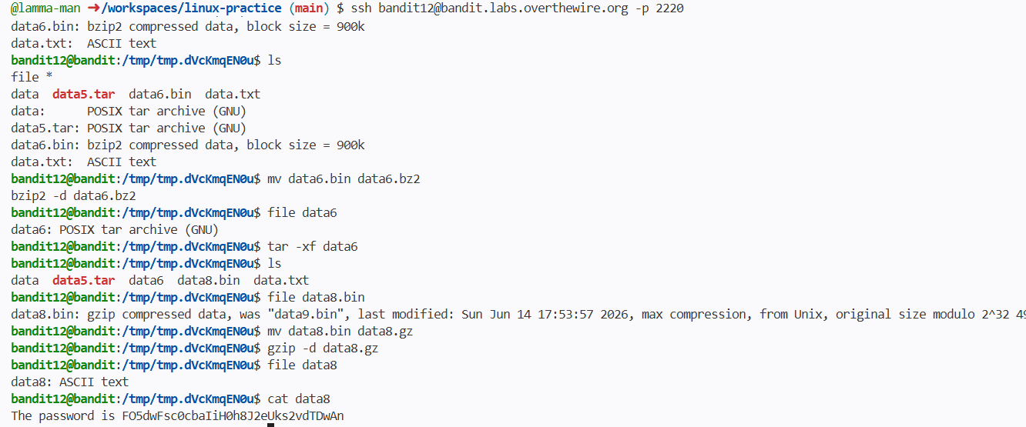

Found password for 13-14th
Learned how to use an SSH private key to log in instead of a password (ssh -i keyfile).
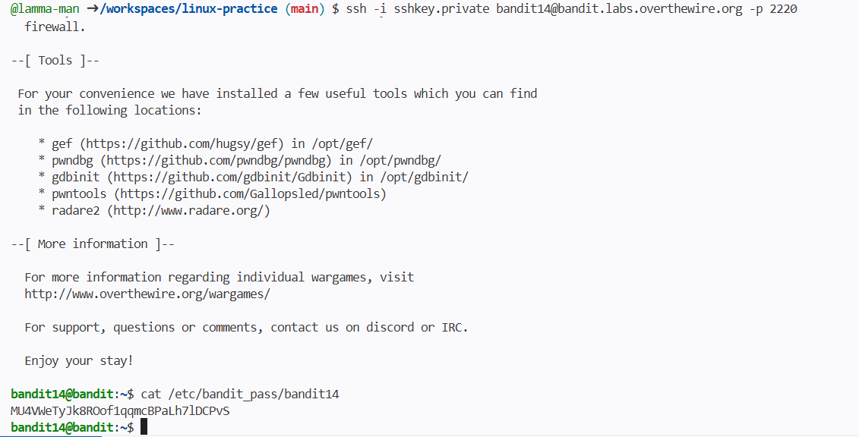
Found pass for 14-15th
Learned how to connect to a network service using nc (netcat) and send a password to receive the next one.
